COA LAB SHEET - 5

1. Write a program that reads two integer numbers A and B. The program must to indicate if one of these numbers is multiple of the other one.

Ans.

Program

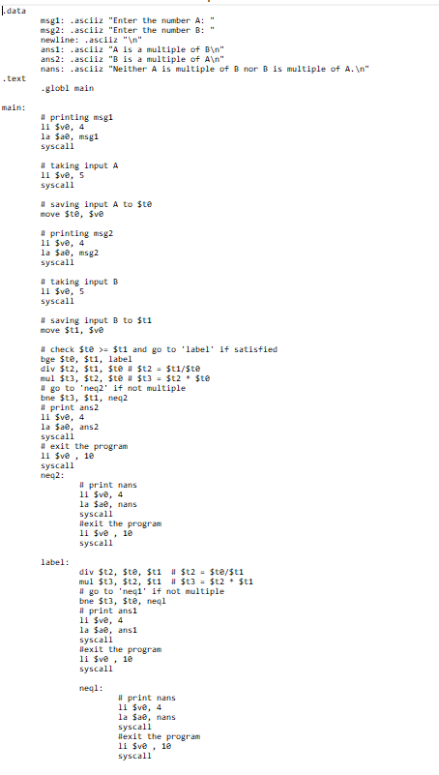

Output

The following output is obtained in two different runs.

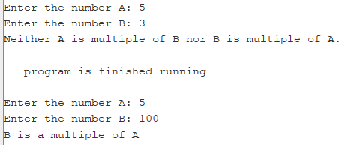

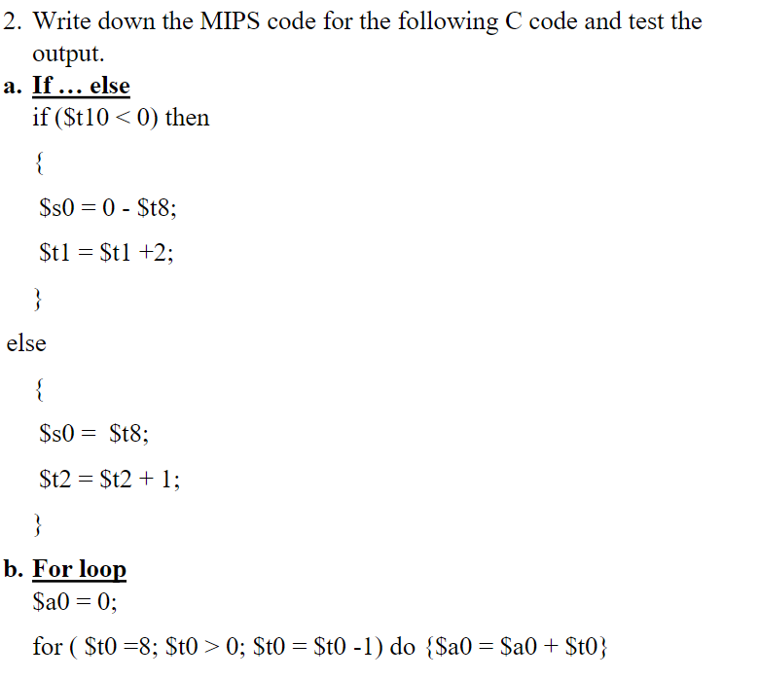

Ans. Taking $t0 instead of $t10 since $t10 is not available.

Program for part a

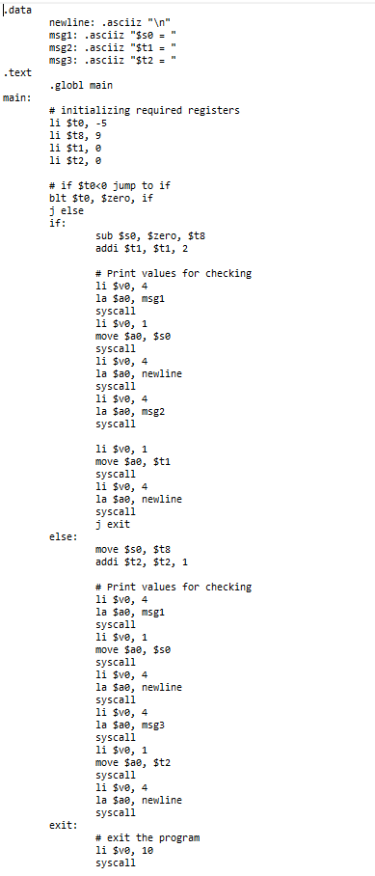

Output for part a

If $t0 < 0



Else



Program for part b

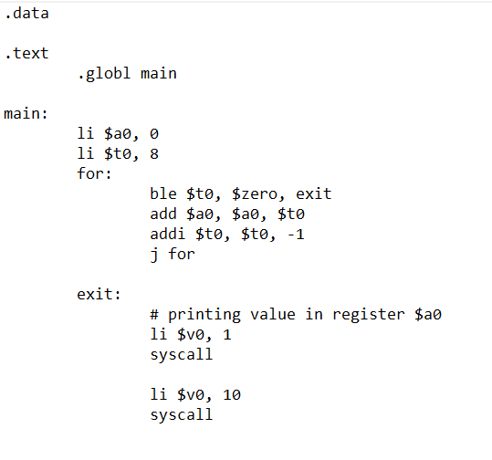

Output for part b



1. . Write the complete assembly language program, including data declarations, that corresponds to the following C code fragment. Make use of the fact that multiplication and division by powers of 2 can be performed most efficiently by shifting.



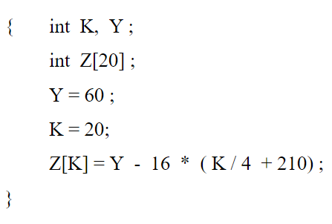

(Please find the answer in the next page.)

Ans.

Program

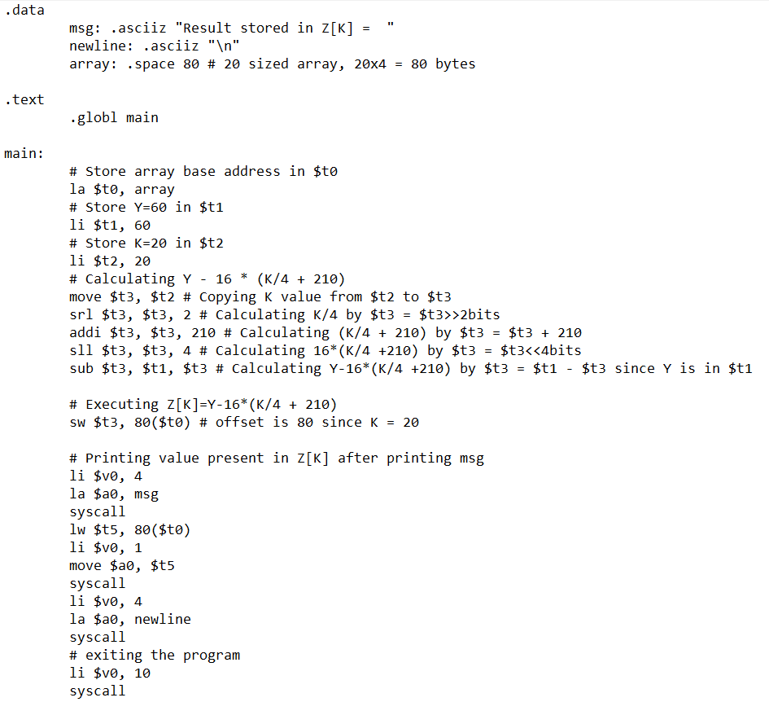

Output

Z[K] where K = 20 is outside the limit of array, so its assignment can manipulate the other values that are written in data section if we declare the array first and the other values later. So, I declared the strings first and then the array.

